Regular Council Meeting

City Hall Mansfield, Washington

January 8, 2025

Mayor Wall called the meeting to order at 6:00 PM.

PRESENT- Mayor Wall, Council members Tupling, Jardine, Foged, Lamar and Bayless. Clerk Sima, Joanna Schiebe, and Mackenzie Jardine.

EXCUSED ABSENCE- None.

UNEXCUSED ABSENCE- None.

PLEDGE OF ALLEGIANCE- The pledge was led by Mayor Wall.

MINUTES- Council member Foged made a motion to accept the December 11, 2024 minutes, Lamar seconded, motion carried.

MANSFIELD SCHOOL ANNEXATION- Clerk Sima informed council that the process is underway. Clerk Sima made available to council the processes that need to take place.

RESOLUTION 2025-MILEAGE REIMBURSEMENT - Discussion followed. Council member Foged made a motion to accept, Tupling seconded, motion carried.

MAYOR REPORT- Mayor Wall informed council that the Town of Mansfield received the Mansfield Legacy Grant, $15,000.00 for tables/chairs and $10,000 for Flags for Mainstreet.

Discussion took place on ordinances and enforcement.

FINANCIAL REPORTS- The bills were read and approved in the amount of $36,087.45 for December 31, 2024. Warrant #5301-5329. Council member Foged made a motion to accept, Lamar seconded, motion carried. The bills were read and approved in the amount of $216,247.72 for January 8, 2025. Warrant #5330-5344. Council member Foged made a motion to accept, Tupling seconded, motion carried.

WARRANT REDEMPTION CHECKS- Check #2256 $3,327.02 #2257 $11,584.56

#2258 $200.00 #2259 $73,593.56

941 EFT- $3,377.32

# RURAL ECONOMIC _DEVELOPMENT 01- $1 ,620.OO

DEPARTMENT OF REVENUE EFT- $1 ,247.75 DOMESTIC WIRE TRANSFER-LGIP-$IO.OO

The Treasurer's report for December 3 1, 2024 was read and approved showing $777,567.12 in checking and investments, motion to approve by Council member Lamar, seconded by Tupling, _motion carried.

There being no further business, the meeting was declared adjourned at approx. 6:36 P.M.

Approved:

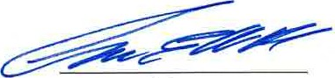

Mayor

Respectively submitted:

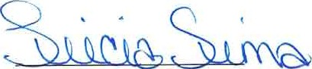

Clerk/Treasurer